Sample of PhysicalVerification Pictures.

The table below illustrates some physical status of the verified assets with photographic evidence.
Table XXX: Physical verification photos
AKALI HC III MATERNITY | 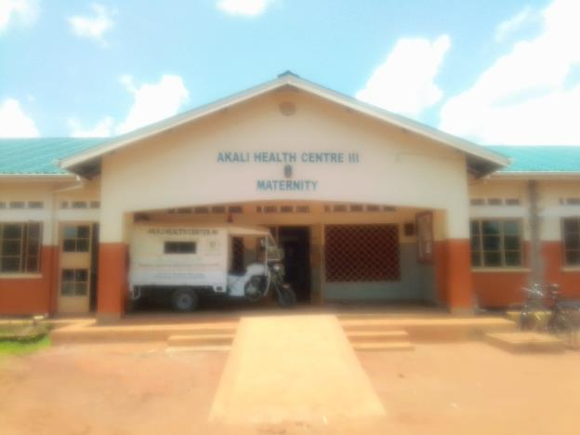
AKALI HC III MATERNITY | 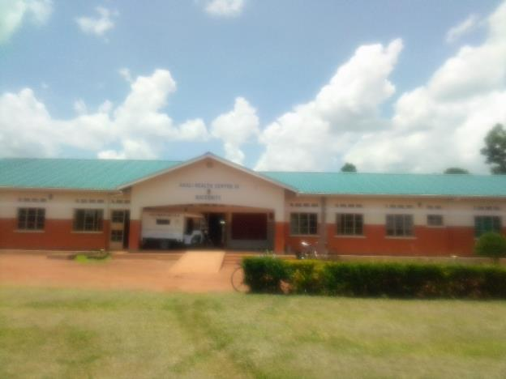
TOILETS | 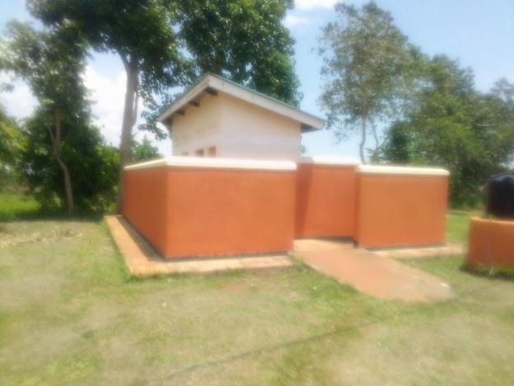
PLACENTA PIT | 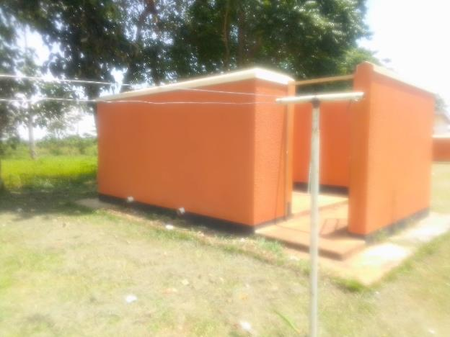
PLACENTA PIT | 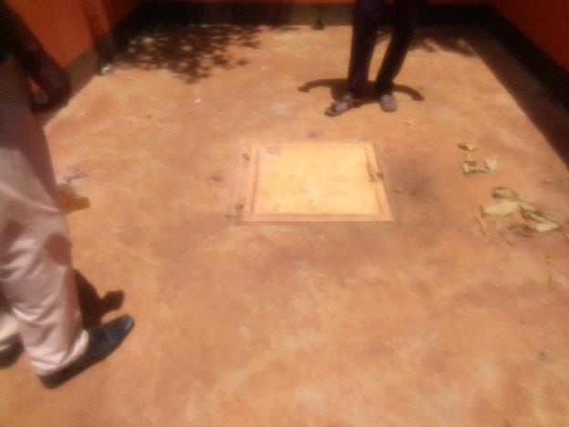
WATER TANK | 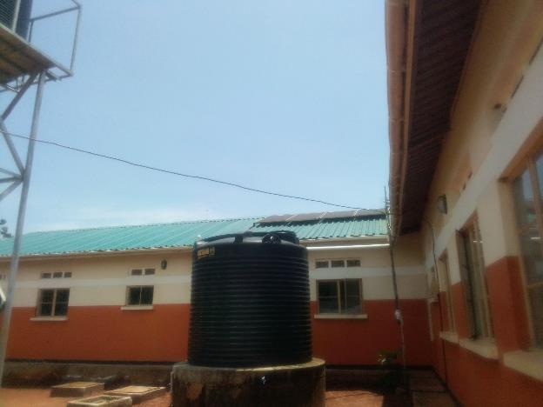
HEAMOGLOBIN METER, DIGITAL | 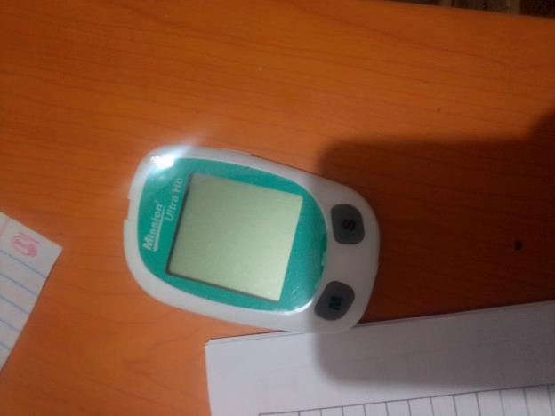
MVA KIT STILL IN STORE | 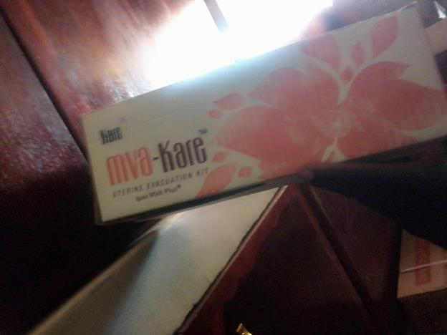
CUPBOARD STEEL | 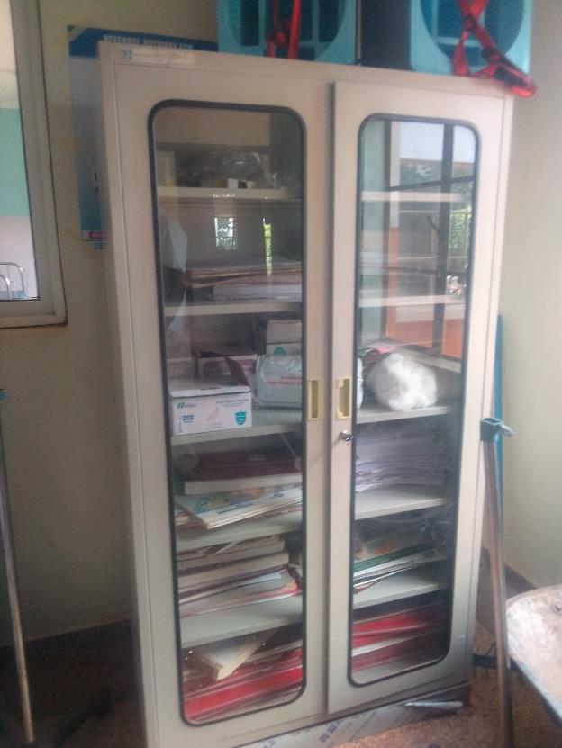
FILLING CABINET | 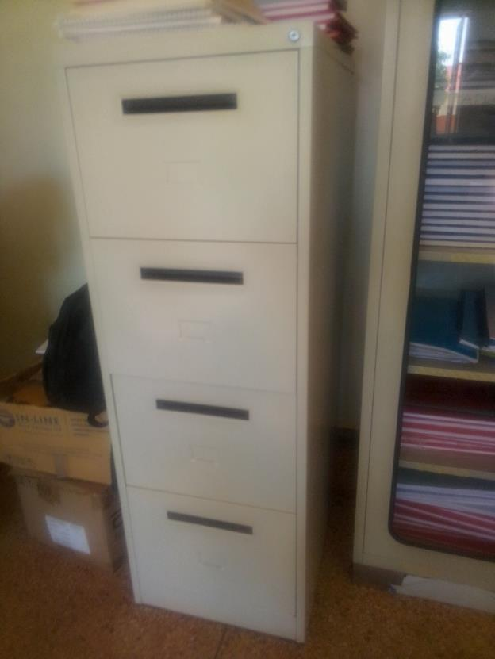
OFFICE CHAIR | 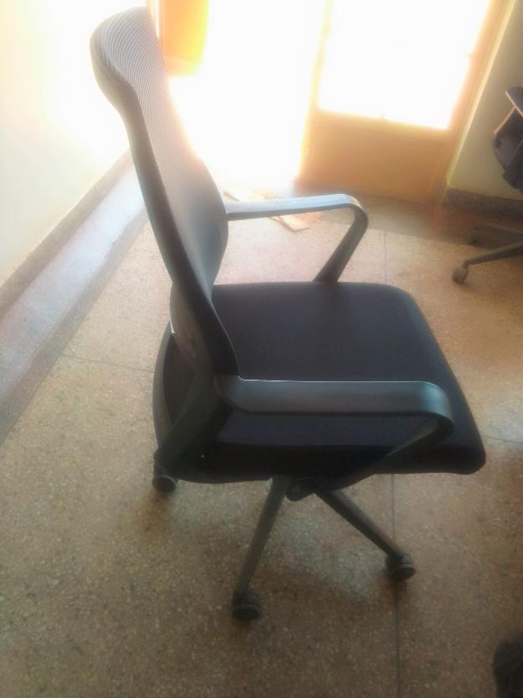
DESK | 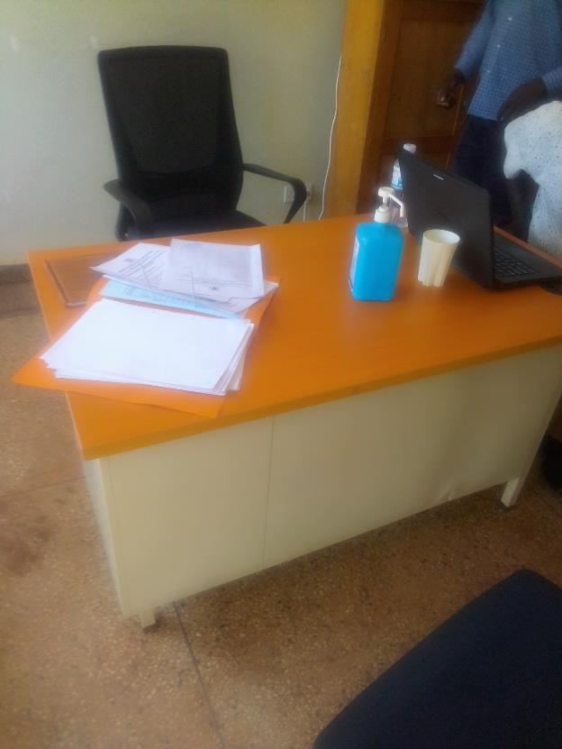
DISINFECTION BUCKETS | 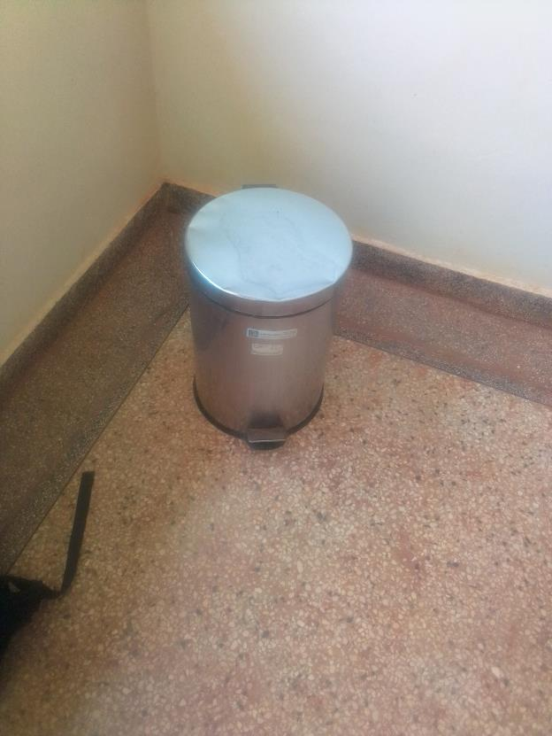
BED, ADULT ATIENT WITH MATTRESS | 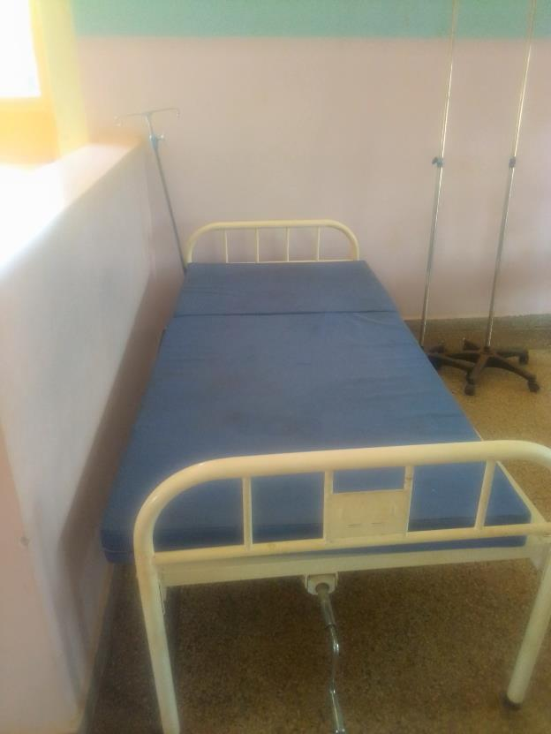
DRIP STANDS | 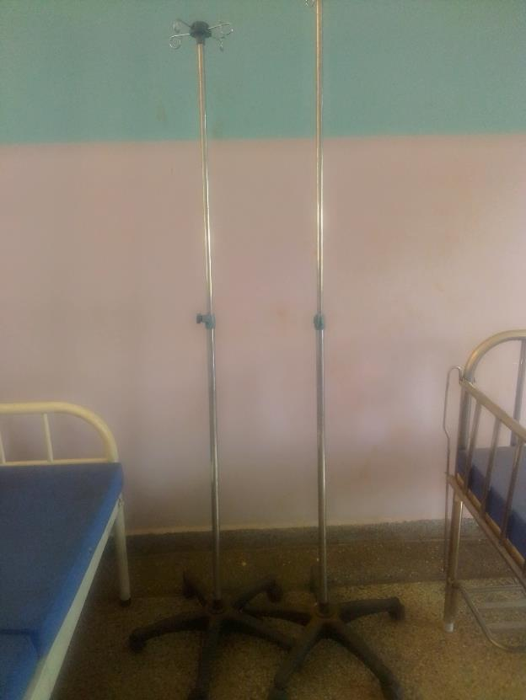
KANGAROO MOTHER CARE CHAIR | 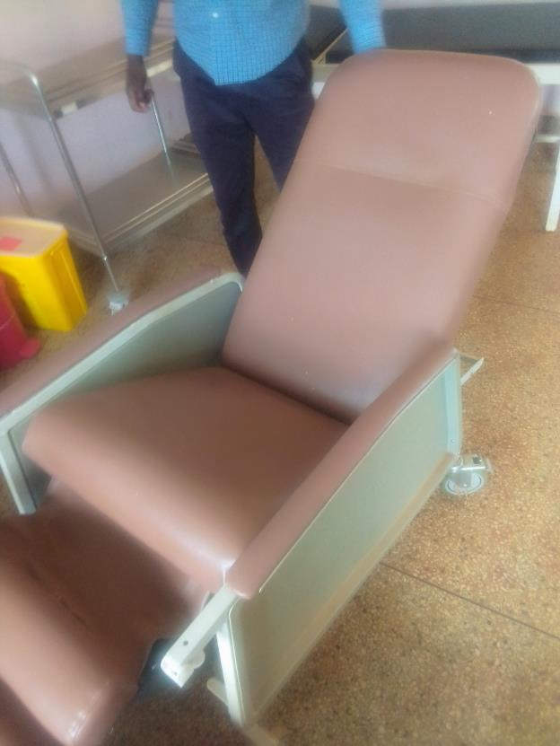
PATIENT SCREEN | 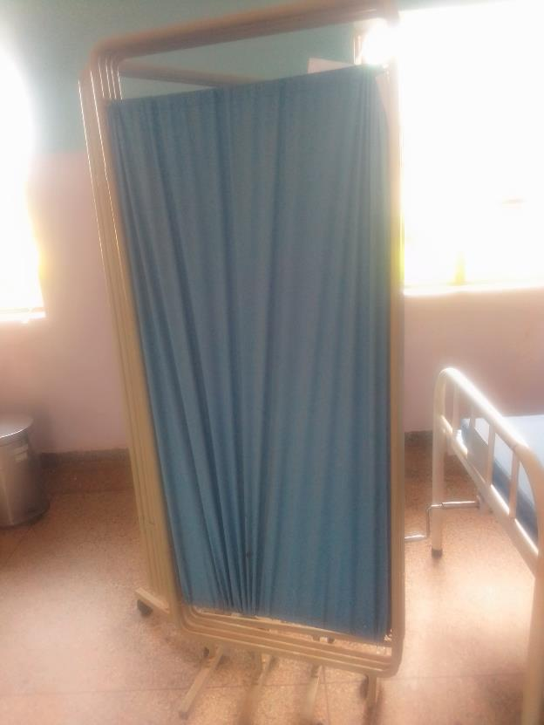
BEDSIDE LOCKER | 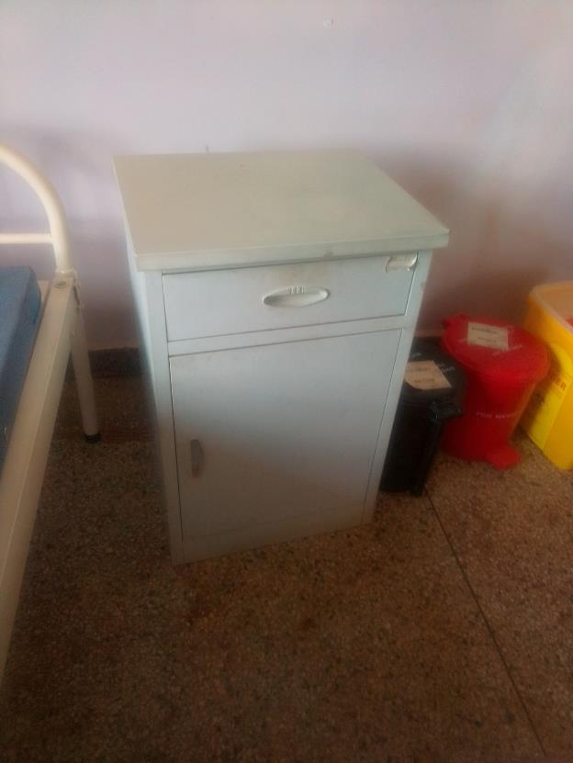
DISINFECTION BUCKETS | 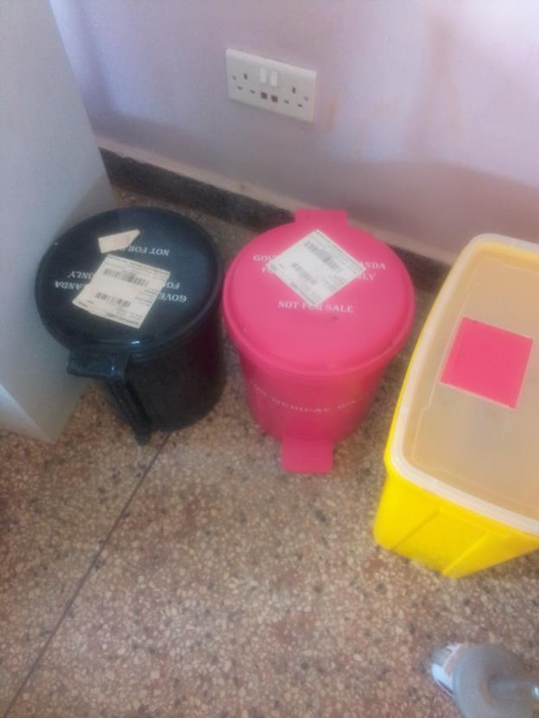
PATIENT TROLLEY | 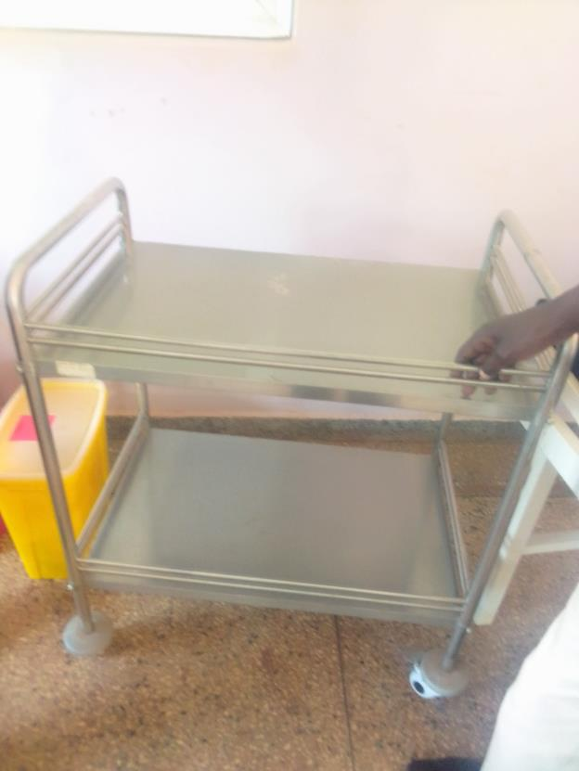
DELIVERY BED | 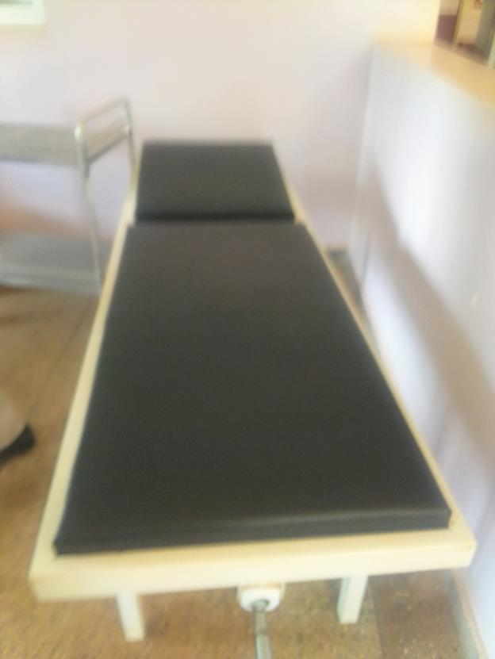
STRETCHER | 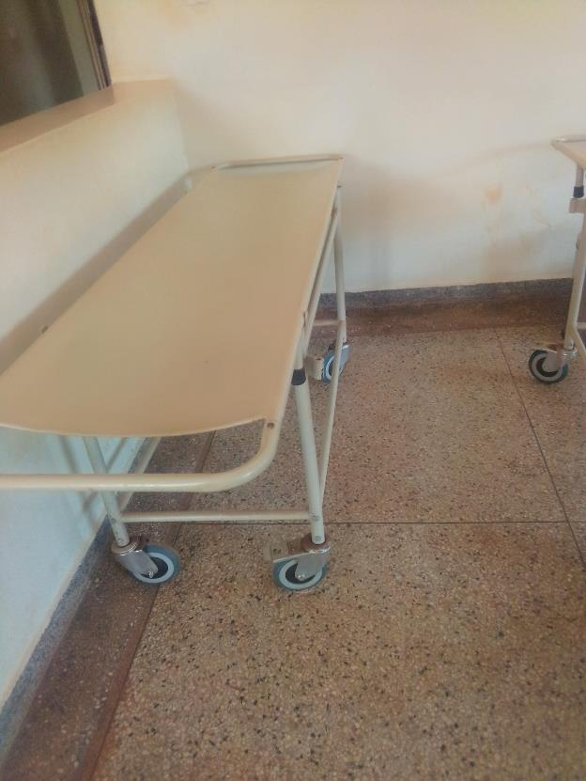
BED, ADULT PATIENT WITH MATTRESS | 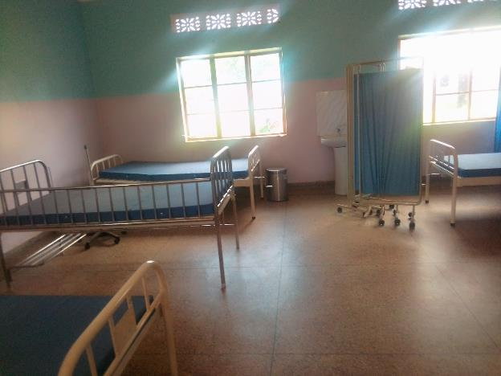
BED, ADULT PATIENT WITH MATTRESS  WITH DRIP STANDS | 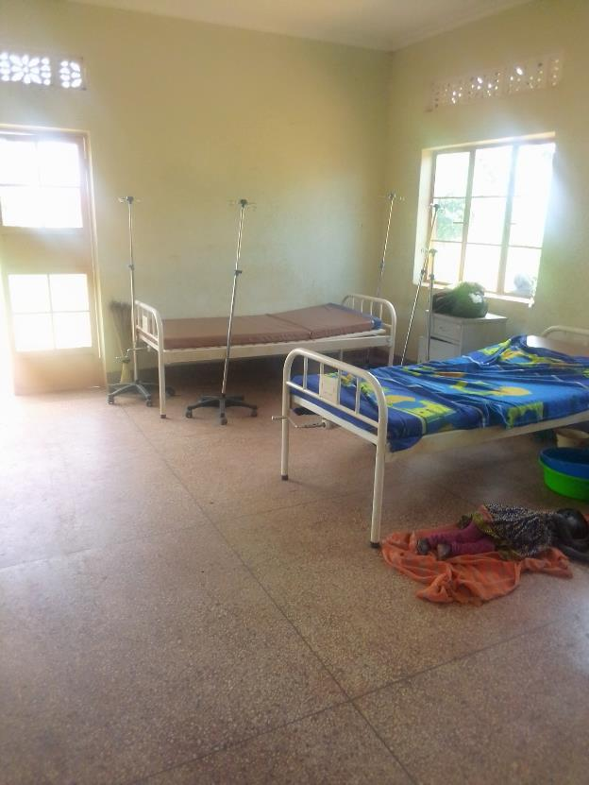
BP MACHINE, DIGITAL | 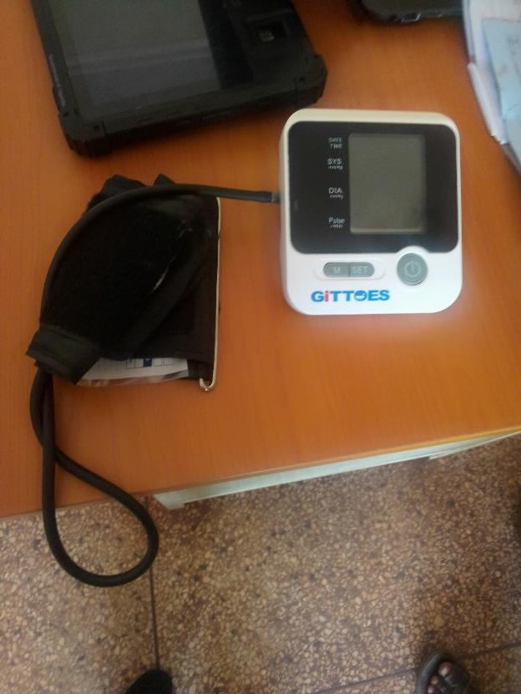
BENCH | 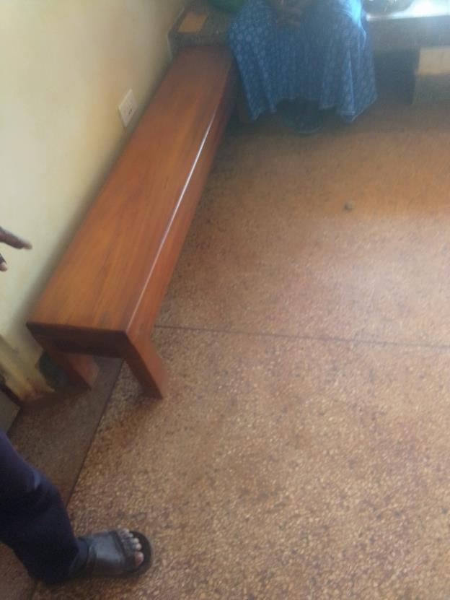
REFRIDGERATOR, BASIC | 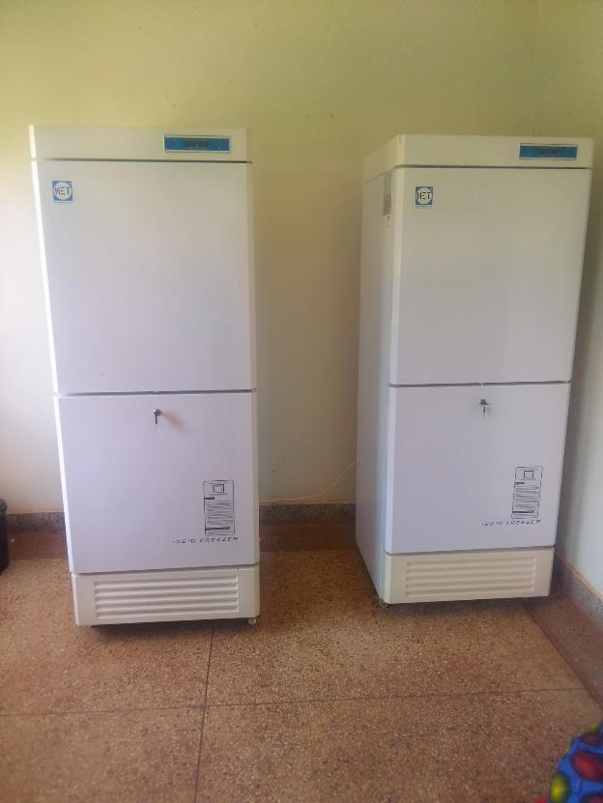
OXYGEN CONCENTRATOR | 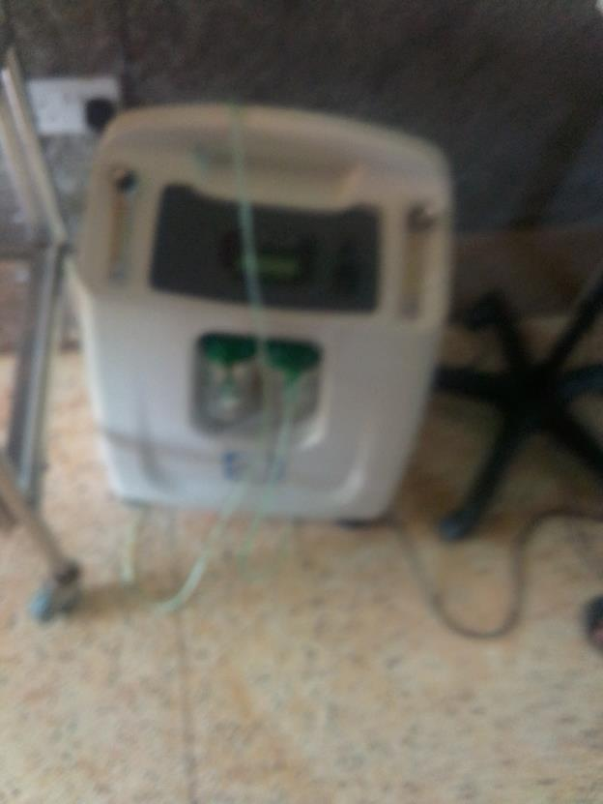
BAY COT | 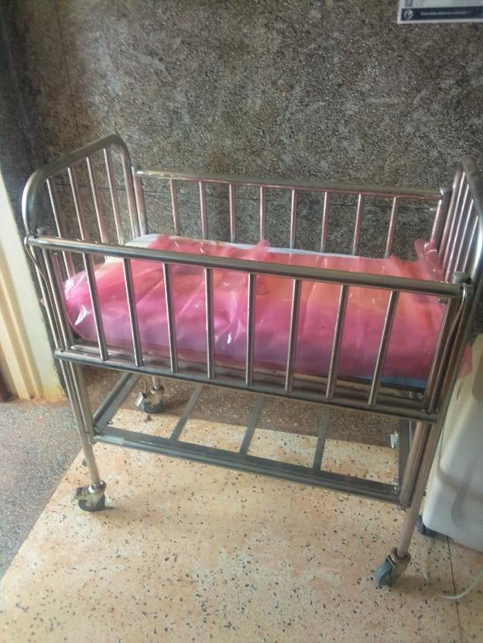
EXAMINATION LIGHT | 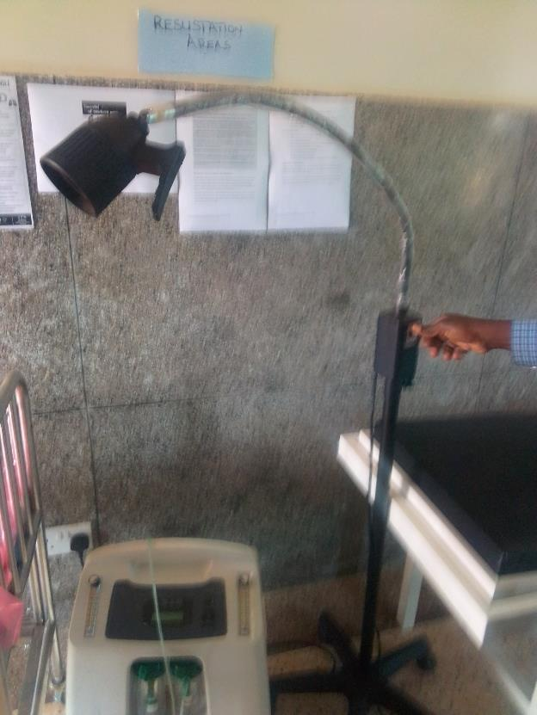
STOOL, LABORATORY | 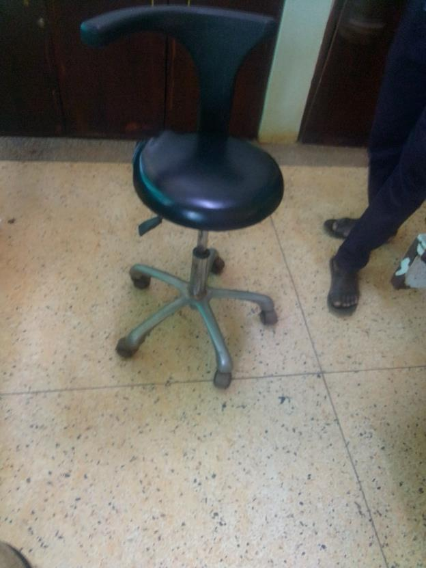
WEUGHING SCALE INFANT | 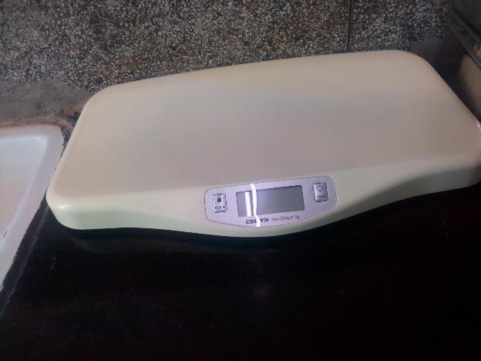
HEIGHT METER  (SPOLIT) | 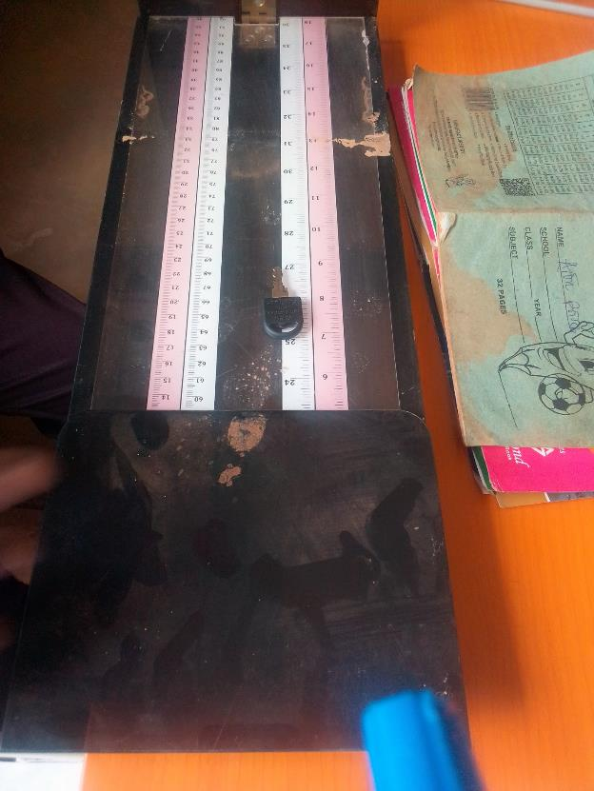
DIAGONISTIC SET SUTURE | 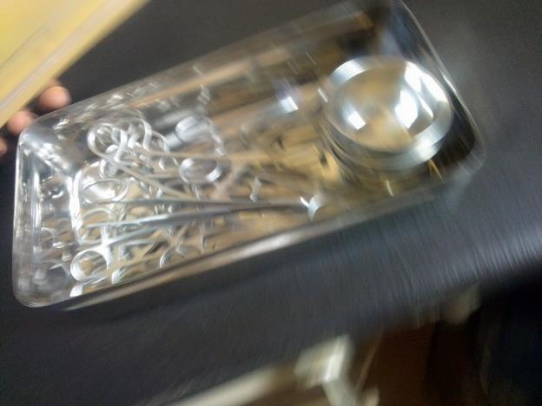
HOLLOW WARE SET WARD | 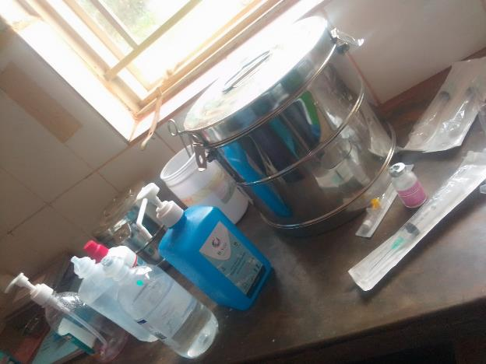
SUCTION APPARATUS | 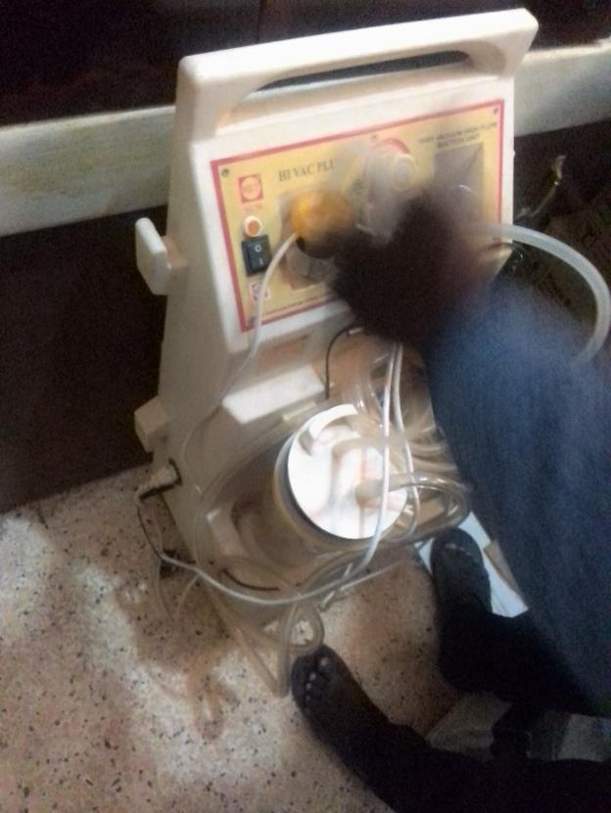
CENTRIFRUGE | 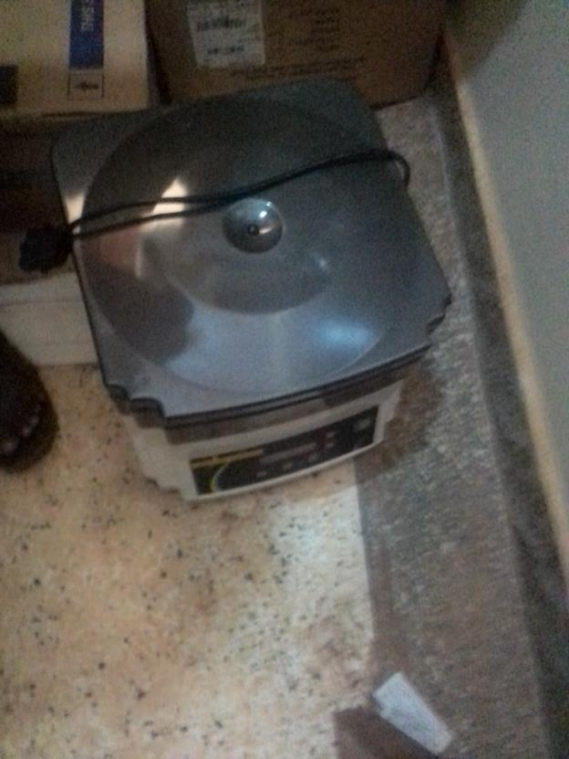
OXYGEN CYLINDER | 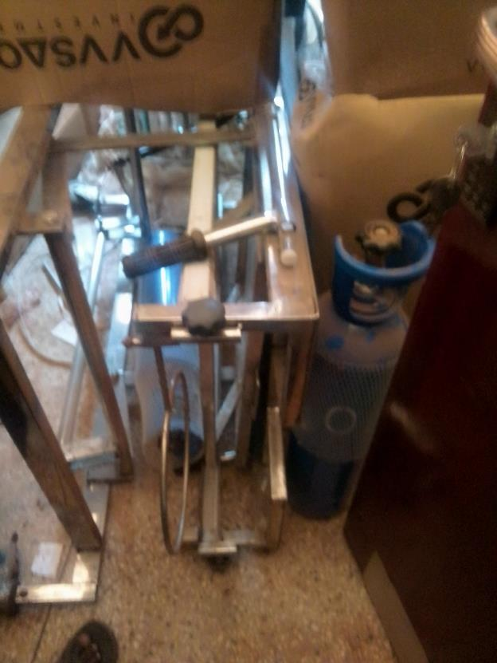
AUTOCLAVE 20 LITRES DUO OPERATED | 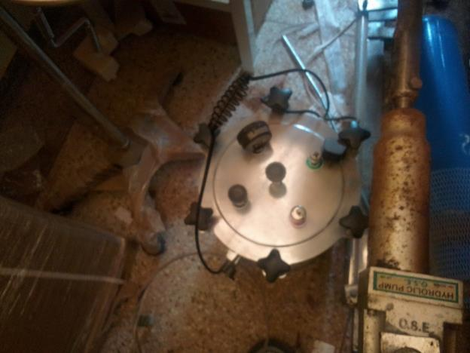
PULSE OXIMETER STILL IN STORE | 